Andrea Benham
Professor Andrea Maison
LA 432 OL 1: Art of Spain: From El Greco to Picasso
December 18, 2023

El Greco, Picasso, and Modernism
The history of Spain and Spanish art is one of contradictions. Catholicism and Islam, strict artistic code and the heights of modernism, intense superstition and religion-less Fascist Nationalism. It’s the blending of these elements and their cultural context that produces some of the most unique art in the Western world. It can be surprising to see, when looking across three hundred years of turbulent history, how two artists who could never have met created something so similar. Both El Greco and Picasso pioneered new styles of painting, bringing the hyper-modern into the classic format of the landscape three hundred years apart. In this paper, themes of modernism will be explored through these artists, as well as what it means to be modern.
El Greco (1541-1614) was born in modern-day Greece on the Isle of Crete. Though he started his painting career in the Venetian Renaissance style he eventually transferred to the mannerist style; the hallmarks of which are elongated figures, flattened planes, bright colors and intense emotion. (Wethey) Style at this time would be difficult to discuss without the acknowledgement of the Tridentine Standards and the counterreformation. While the Protestant Reformation was taking over Northwestern Europe, Catholic cultures to the south were mounting their own counterreformation, strengthening the power of the Catholic Church. To this end the Council of Trent imposed a series of standards that had to be met when creating art. (Wethey) And while El Greco respected those standards, he was able to create his own style as well. At a time when Renaissance realism and perfect three-point perspective was the height of art, El Greco did something totally the opposite and, for lack of a better term, modern. While the drama in his dark colors is consistent with the Renaissance period, the representational forms rather than realism would have been bizarre and puzzling to a contemporary audience. (Wethey) His work could easily be confused for works from the 20th century with their dream-like qualities and simultaneity of form. It cannot be overstated how different this was to anything other artists were doing at the time. While Renaissance artists adored both religious imagery and stirring emotion, their style of painting was incredibly different. Consider a classic Rembrandt to contrast the similarities. The strokes are smooth, the gradients perfect from one light source to another. The human face or object is rendered as close to life as can be. Though his religious works gained him fame, it is the landscape “View of Toledo” this paper is interested in and what we will be comparing the imaginary Rembrandt to. (Fig. 1) It also follows mannerist characteristics, showing long buildings of a height not possible to build at the time, intensely white, contrasting with the dark sky. Now, observe “View of Toledo”. Brush strokes are visible as if in an almost impressionistic state. Light is directly next to dark with no transition, flattening the image. Nothing appears rounded or three-dimensional. Much as people today are off put by hyper-modern art and how it challenges convention, it is easy to imagine how El Greco’s contemporaries would fail to understand his style. Though it is not a lack of contemporary understanding that makes a piece ‘modern’, it certainly seems to be a theme in the reception of modern art. While El Greco had an impressive career, he never found favor with the Spanish Court of the day and mostly did personal or religious commissions. (Wethey)
Pablo Picasso (1881-1973) is perhaps the most well-known artist of the 20th century. Art had changed much since El Greco was the premiant Spanish artist, and so had the world. Picasso mostly lived in Paris where the avant-garde scene was thriving. By the time Picasso was an emerging artist photography had been invented, dispelling the need for realism that humanity has chased in its art in one form or another since the beginning of time. Where was painting to go now when any scene could be captured perfectly in the click of a shutter? Some, like Picasso, thought that art had to change directions from the millennia old practice of naturalism to survive. To this end he rejected the illusionistic tricks Western art had used to depict three-dimensional objects on canvas since the Renaissance. He practically invented what we consider modern art with this revelation. (Brettell, 33) While the impressionists had allowed for more freedom of brush stroke and light, it was the Cubists that broke down the three-dimensional form altogether. Simultaneity, mentioned earlier, is the viewing of one object in several views at once, something impossible to do in real life. (Green, 197) El Greco arguably used an early form of it to show multiple events with the same person at one time on one canvas, but its Picasso who truly invented it. His work “The Reservoir, Horta de Ebro” is a landscape of simultaneity. It is hard to even recognize as a landscape, but the elements are there. (Ganteführer-Trier, 38) Buildings, grass, a bridge, the sky. The more you look the more you can identify: a road winding up to houses with doors and windows, the shadows these places cast. Even something that looks like a church is recognizable. It is possible to get the sense of a small rural town on a hill at sunset or sunrise. Like the impressionists and indeed El Greco, the brushstrokes are noticeable, but more ordered than either previous example. The colors are muted and neutral, the tans and pinks in the buildings suggesting a cloudy sunrise or sunset. Though a simple piece, it is one that comes at the very birth of Cubism and true modern art.
Despite its modernism, El Greco has made what is recognizable as a landscape, while Picasso’s piece would be seen first as a cubist piece first and a landscape second. Without historical context these two pieces could not outwardly be more different. It would be a waste to go through the ways they are different when those are so visually clear, and instead focus will be on how they are different in the way of notches on a sliding scale. “Reservoir”, let’s say, is further along a scale in the direction of modernism than “View of Toledo”, but both are further along than a truly naturalist painting that would inhabit the other end. Seen by the public, this naturalist to modernist landscape scale would possibly be described as “landscape” at one end, “weird landscape” when arriving at “View of Toledo” and “abstract” when reaching “Reservoir” at the other. In this respect, comparing the two paintings is done in this manner to avoid obvious phrases like ‘El Greco uses more colors’ or ‘Picasso has a more distinct line weight’. These are things known with a simple glance that do not need to be written up in a paper. Regarding their perceived modernism, it is important to remember the conditions each piece was made under. Though the artistic conclusion is similar, there is no world in which these are the same painting made with the same artistic intention. Picasso was looking to revolutionize painting for the sake of reinventing the medium. El Greco, we assume, was looking to do no such thing. Though there are considerably less interviews with him than Picasso, by examining the time we can at least understand what his interests and intentions might have been. He was a humanist, deep into the mysticism scene of Spain, and therefore was most likely inventing this style to be able to depict things beyond human comprehension. (Wethey) Why would heaven be naturalistic, on one plane? He needed a new way to represent the divine, the mystic. Representation over realism in the time of El Greco meant perfectly rendered mythic allegory to allude to the events and values of the time, not images that literally chose to be unrealistic to cause emotion. However, that is just what he did. His motives were most likely religious to create his simultaneous visions, while Picasso was doing something more akin to a science experiment. (Brettell, 98) It’s fascinating they had nearly the same conclusion.
Though they lived three hundred years apart and do not share a birth country, El Greco and Picasso managed to create very modern and very Spanish pieces centuries apart. Though Modern Art is a movement that took place in the 20th century, modern art can be any piece that is at the forefront of innovation at its time. Even more than that, the distinct similarities between Picasso and El Greco make a closer connection even than them both being visionaries in their own time. It is truly astounding that El Greco was painting simultaneous flattened forms on a single plane three hundred years before the invention of the camera made it necessary for Picasso to rethink painting altogether and come to the same conclusion. Salvador Dali would be interesting to bring into this discussion as well; his spindly figures and religious imagery would be an interesting surrealist counterbalance to Picasso’s style and match up nicely with El Greco’s elongated figures. It would be wonderful to see these three men critique each other’s work. I believe they would be in favor of each other. In conclusion, Spanish art is full of contradictions, and more than a few coincidences.

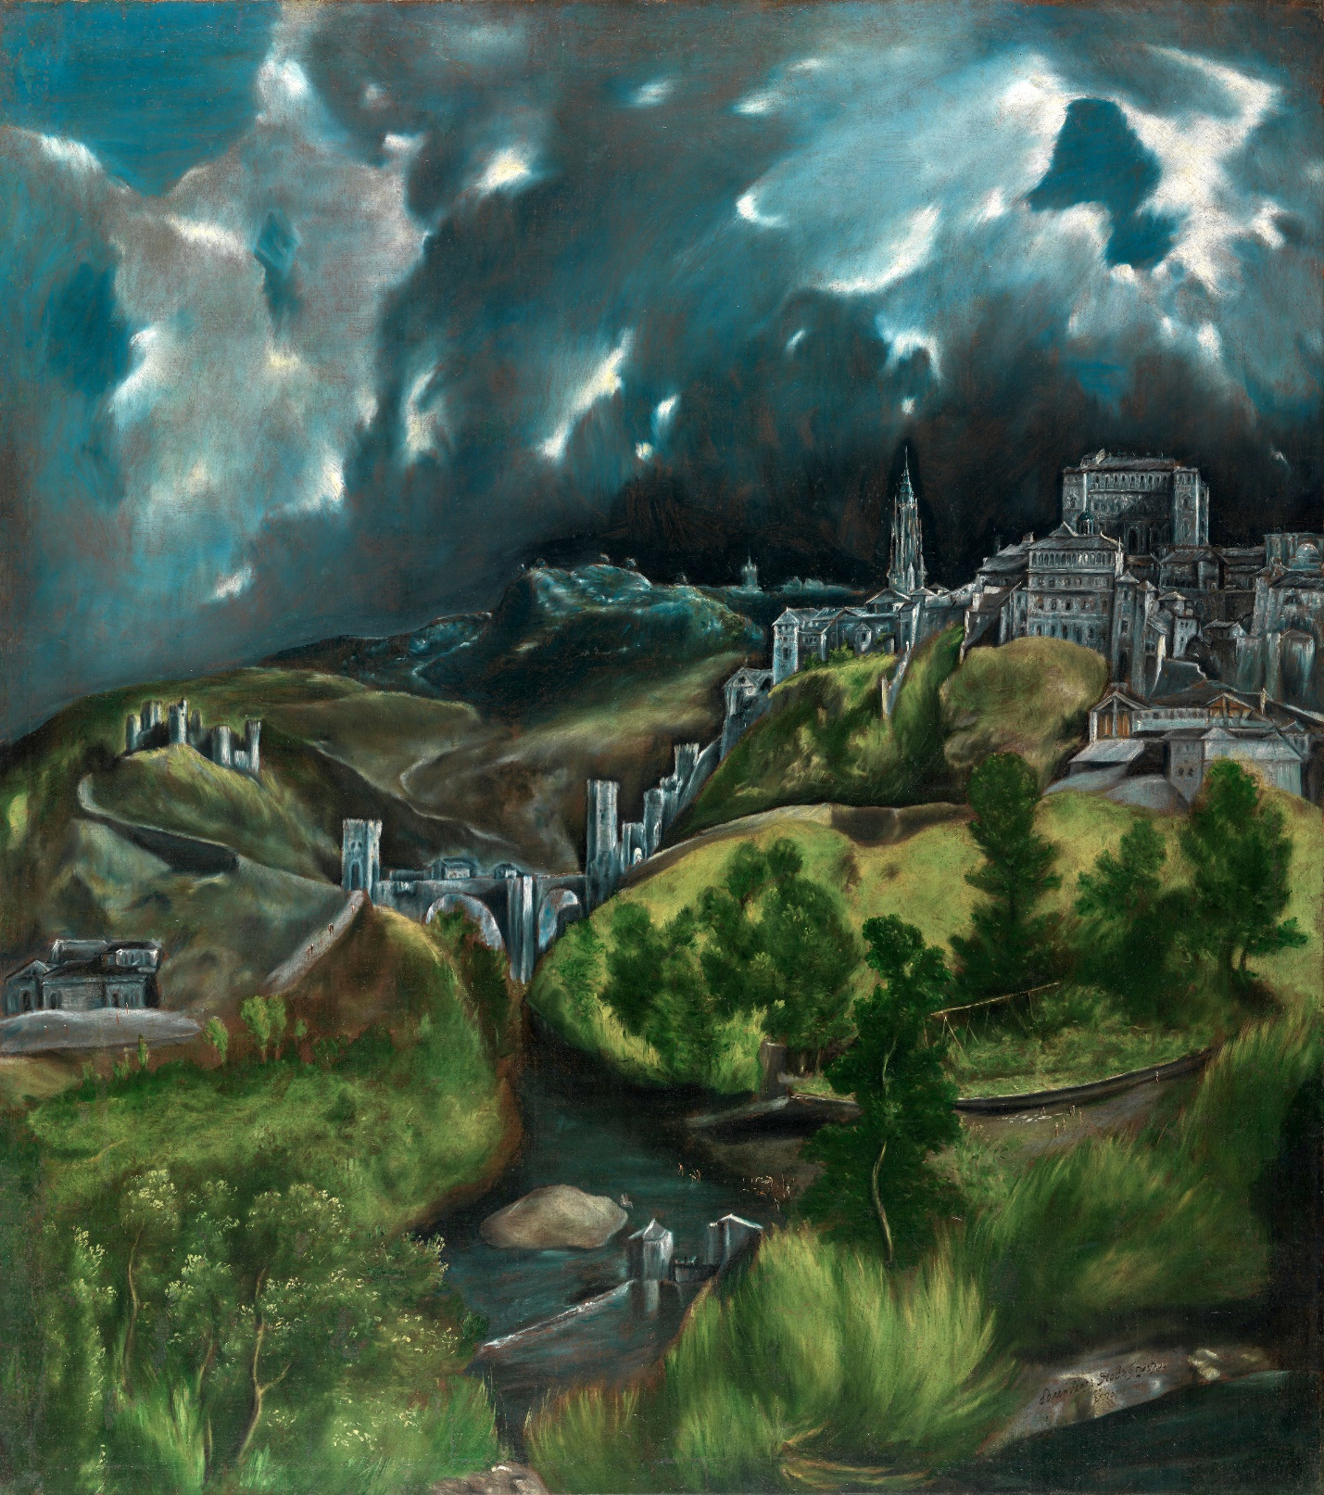
Fig. 1: El Greco, “View of Toledo”, 1596–1600, Mannerism, Metropolitan Museum of Art, New York.

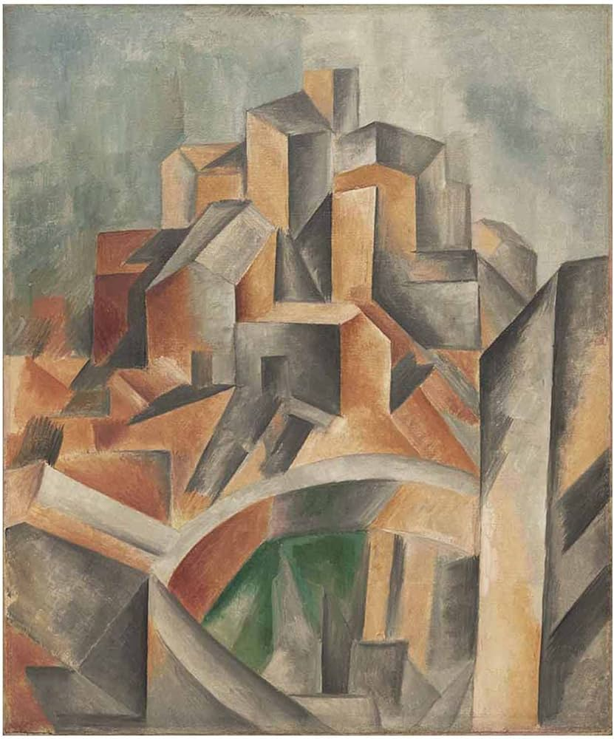
Fig. 2: Picasso, “The Reservoir, Horta de Ebro”, 1909, Cubism, Museum of Modern Art, New York.

Works Cited
Brettell, Richard R. Modern Art, 1851-1929: Capitalism and Representation. United Kingdom, Oxford University Press, 1999.
Delphi Complete Works of El Greco (Illustrated). United Kingdom, Delphi Classics, 2017.
Ganteführer-Trier, Anne, and Grosenick, Uta. Cubism. Germany, Taschen, 2006.
Green, Christopher, and Picasso, Pablo. Picasso: Architecture and Vertigo. United Kingdom, Yale University Press, 2005.
Wethey, Harold E. "El Greco". Encyclopedia Britannica, 1 Dec. 2023, https://www.britannica.com/biography/El-Greco. Accessed 2 December 2023.

